FEATURES
Platform height elevated 9,68 m
Overall width 1,17 m
Platform capacity 320 kg
Roll out deck extension 1,27 m
Fold-down handrails
Lanyard attach points
Proportional hydrostatic drive control with thumb steer
Proportional lift up
GLOBEN, S.L.
C/Germán Bernácer 95
Elche Parque Empresarial
Apdo. De Correos 5154·03203 ELCHE (Alicante)
Telf. 966 299 599 · Móvil 673 823 100
Fax 965 680 523 · info@globen.es
www.globen.es
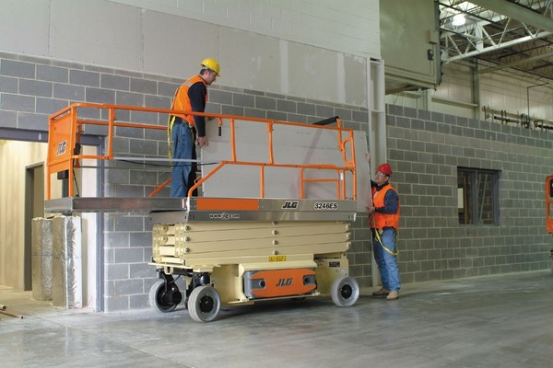
ELECTRIC SCISSOR LIFT
JLG 3246ES 12M HEIGHT

DIMENSIONS
A. Platform height (elevated) | 9.68 m
B. Platform height (lowered) | 1.26 m
C. Platform railing height | 1.10 m
D. Overall height rails lowered | 1.97 m
E. Platform size | 1.12 m x 2.50 m
F. Platform extension | 1.27 m
G. Overall width | 1.17 m
H. Overall height | 2.50 m
I. Wheelbase | 2.09 m
J. Ground clearance | 0.13 m
Platform capacity¹ | 320 kg
Capacity on platform extension | 120 kg
Lift/lower time | 50/60 sec.
Maximum drive height | 9.68 m
Platform weight | 2,870 kg
Ground bearing pressure | 6.90 kg/cm²
Drive speed lowered | 4.0 km/h
Drive speed elevated | 0.8 km/h
Gradeability | 25%
Turning radius (intern) | 0
Turning radius (extern) | 2.41 m
Tires | 406 x 125
Brakes | Electric, automatic friction
Drive | 24V electric 6 kW
Batteries | 4 x 6V 220 A/hr
Charger | (120/240V – 50/60HZ) 20 amp automatic
Electric motor | 3 kW
Hydraulic reservoir | 20.0 L
¹Capabilities provided with a maximum of 2 people inside.
