ENGINE POWERED SCISSOR LIFT
JLG 500RTS 17M HEIGHT

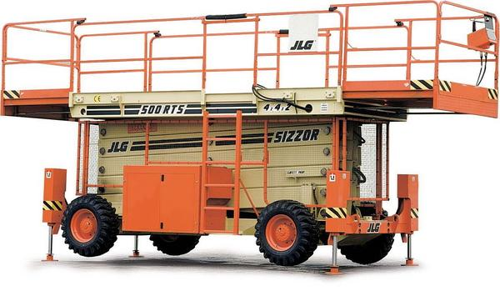

GLOBEN, S.L.
C/Germán Bernácer 95
Elche Parque Empresarial
Apdo. De Correos 5154·03203 ELCHE (Alicante)
Telf. 966 299 599 · Móvil 673 823 100
Fax 965 680 523 · info@globen.es
www.globen.es
DIMENSIONS
A. Platform height (elevated) | 15.24 m
B. Platform height (lowered) | 2.03 m
C. Platform railing height¹ | 1.10 m
D. Overall height (rails lowered)¹ | 2.45 m
E. Platform size | 1.80 m x 4.27 m
F. Platform extension² | 1.23 m
G. Overall width | 2.29 m
H. Overall length | 4.70 m
I. Wheelbase | 3.10 m
J. Ground clearance | 0.30 m
Platform capacity | 1,134 kg
Capacity with dual extension | 910 kg
Capacity on platfom extension | 265 kg
Lift/lower time | 72/72 sec.
Maximum drive height | 6.99 m
Platform extension front | (Optional) hydraulic
Platform extension rear | (Optional) hydraulic
Weight³ | 8,200 kg
Speed 4x2x2 | 5.6 km/h
Speed 4x4x2 (optional) | 4.5 km/h
Gradeability 4x2x2 | 35%
Gradeability 4x4x2 (opcional) | 45%
Turning radius (intern) (simple direction) | 4.01 m
Turning radius (intern) (double direction) | 1.98 m
Turning radius (extern) (simple direction) | 5.72 m
Turning radius (extern) (double direction) | 3.68 m
Axle (optional) | 0.20 m
Tires | 12 x 16.5
Diesel fuel engine | 30 kW Deutz F3L1011
Fuel tank capacity | 56.8 L
Hydraulic reservoir | 140 L
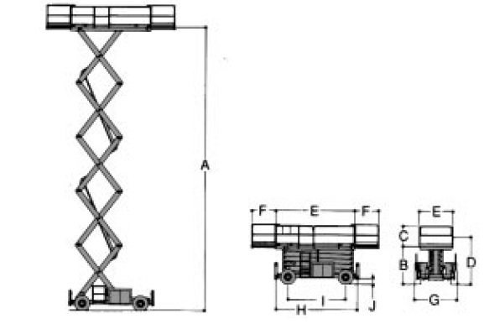
¹ With the optional sliding side increases the height at 0.08 m.
² Optionally 500RTS model with hydraulic sliding single or double side 1.23 m.
³ Weights and dimensions may vary due to each country's regulations or the options.

